Week 3

1. Which of the following statements concerning the failure rate of a component, μ, are true? (Select all that apply).

* **The failure rate of a component, μ, is often taken to be an average, constant value when making calculations for component reliability and failure probability.**
* The failure rate of a component, μ, is highest at the beginning and the end of the component’s useful lifespan.
* The failure rate of a component, μ, is constant throughout the component’s lifetime.
* **The failure rate of a component, μ, is estimated based on historical data.**

1. A component has a predicted failure rate of 0.5 faults/yr. What is the reliability of this component over a 3-year time period?

* 0.777
* **0.607**
* **0.223**
* **0.393**

1. Considering the event tree shown below, what is the probability, in occurrences/yr, that Result B occurs?

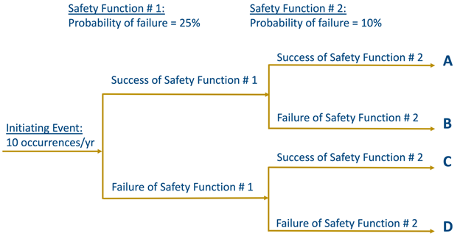

* 0.25 occurrences/yr
* 2.25 occurrences/yr
* 6.75 occurrences/yr
* **0.75 occurrences/yr**

1. .A system involves 3 components in series. The first component has a reliability of .83, the second has a reliability of 0.75, and the third has a reliability of 0.67. What is the reliability of this three-component system?
   * **0.417**

* 0.986
* 0.014
* 0.583

1. Considering the event tree shown below, what is the probability, in occurrences/yr, that Result D occurs?
   * **0.25 occurrences/yr**

* 2.25 occurrences/yr
* 0.75 occurrences/yr
* 6.75 occurrences/yr

1. A system involves 3 components in parallel. The first component has a probability of failure (P) of .10, the second has a (P) of 0.17, and the third has a (P) of 0.22. What is the probability of failure (P) of this three-component system?

* 0.49
* 0.417
* 0.583
* **0.00374**

1. For a revealed failure, the component in question on average is in operation for 45-days before experiencing a failure. The component takes 3-days on average to repair. What is the availability of this component?
   * 0.0625
   * **0.9375**
   * 0.9333
   * 0.875
2. For a revealed failure, the component in question on average is in operation for 45-days before experiencing a failure. The component takes 3-days on average to repair. What is the mean time between failures for this component?
   * **42-days**
   * **90-days**

* **48-days**
  + 6-days

1. Considering the event tree shown below, what is the probability, in occurrences/yr, that Result C occurs?



* **2.25 occurrences/yr**
* **0.25 occurrences/yr**
* **0.75 occurrences/yr**
* **6.75 occurrences/yr**

1. For an unrevealed failure, the component in question on average is in operation for 50-days before experiencing a failure. Inspections occur every two months (61-days), so on average 11-days elapse before the failure is noticed. Once identified, the component can be repaired within the day. What is the unavailability of this component?

* **0.82**
* **0.45**
* 0.40
* **0.18**